Multi-tube Vortexer—MS200
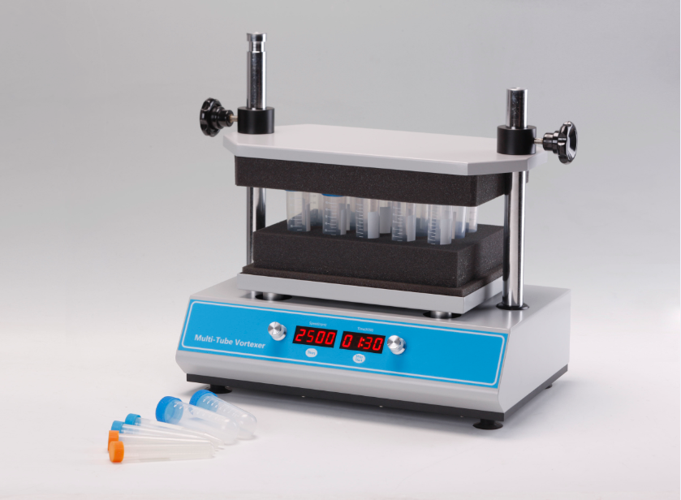

Description:
Multi-Tube Vortexer is with technique of brushless DC motor and microprocessor controlled technique. Unique knob operation is easy to use. It can maximum process 50 samples at once. A variety of test tube foams can be selected to meet the mixing needs of different test tubes. It can be widely used in the biotechnology, microbiology, medical analysis and other industries.
Features:
- LED displays time and shaking speed.
- Easy to operate with one-touch knob.
- 1min~99h59min time range, automatic warning sound when finish working.
- A variety of test tube foam racks for option to meet the mixing needs of different test tubes.
- Soft start, uniform acceleration, effectively avoid samples splashing.
- Brushless DC motor: precise shaking speed, long service life maintenance-free.
- Process up to 50 samples at a time to make the experiment more convenient and efficient.
- Microprocessor control, simple operation panel, LED displays for speed and time.
- Humanized program design, built-in short mix and timing operation modes.
Parameters
Project | Parameter
Speed range | 500~2500rpm
Orbit | 4mm
Temp setting range | 1min ~100hour
Max load | 4.5kg
Power supply | 70W
Voltage | AC110~220V 50/60Hz
Capacity | Type | Foam rack | Test tube
Capacity | MS200-T10 | 50x￠10mm | ￠9~￠10mm
Capacity | MS200-T12 | 50x￠12mm | ￠11~￠13mm
Capacity | MS200-T15 | 50x￠15mm | ￠14~￠17mm
Capacity | MS200-T20 | 50x￠20mm | ￠18~￠21mm
Capacity | MS200-T25 | 15x￠25mm | ￠24~￠27mm
Capacity | MS200-T29 | 15x￠29mm | ￠28~￠32mm
Dimension(mm) | 410x276x432
Weight(kg) | 20

